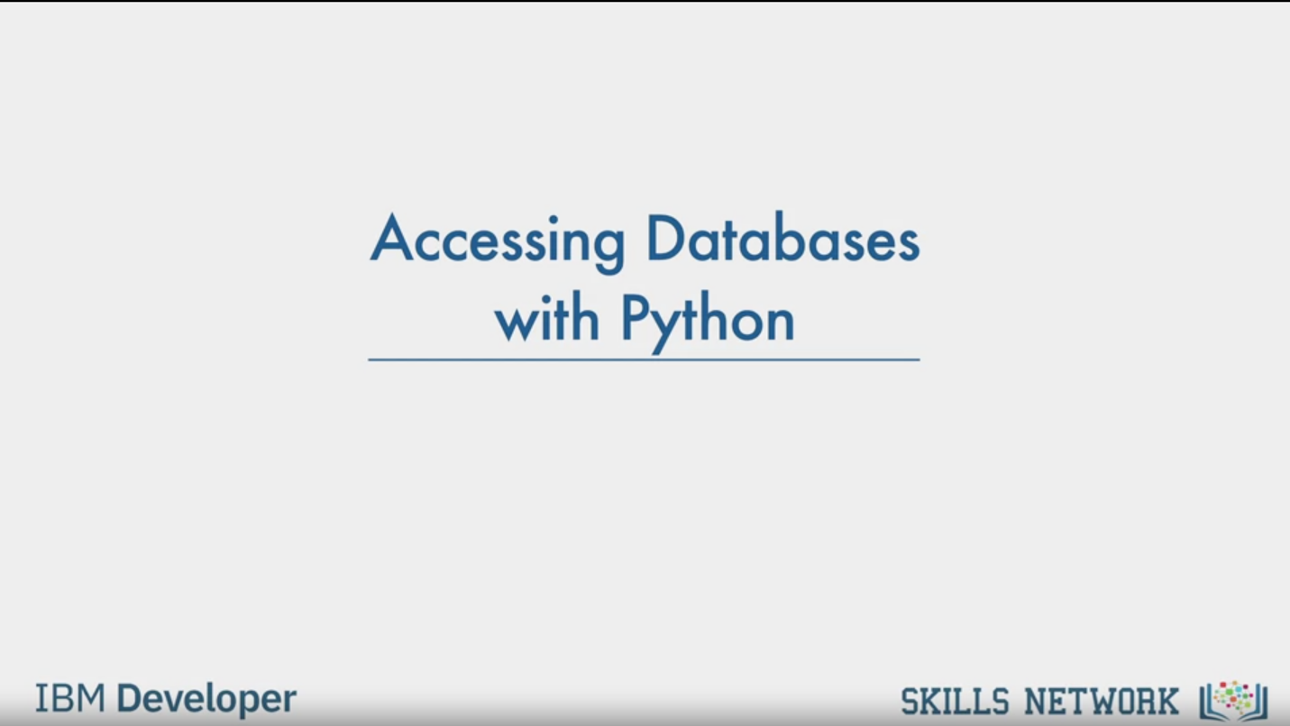

Accessing Databases

with Python

IBM Developer

SKILLS NETWORK

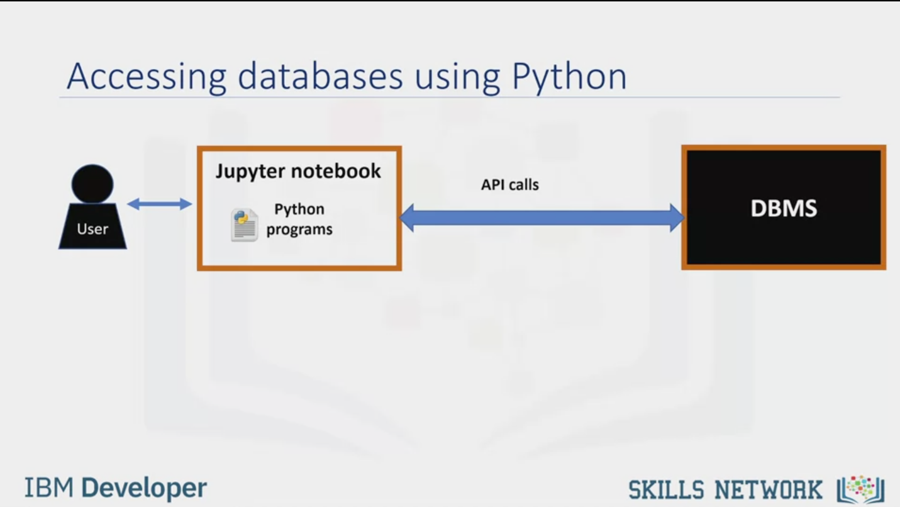

Accessing databases using Python

User

Jupyter notebook

Python

programs

API calls

DBMS

IBM Developer

SKILLS NETWORK

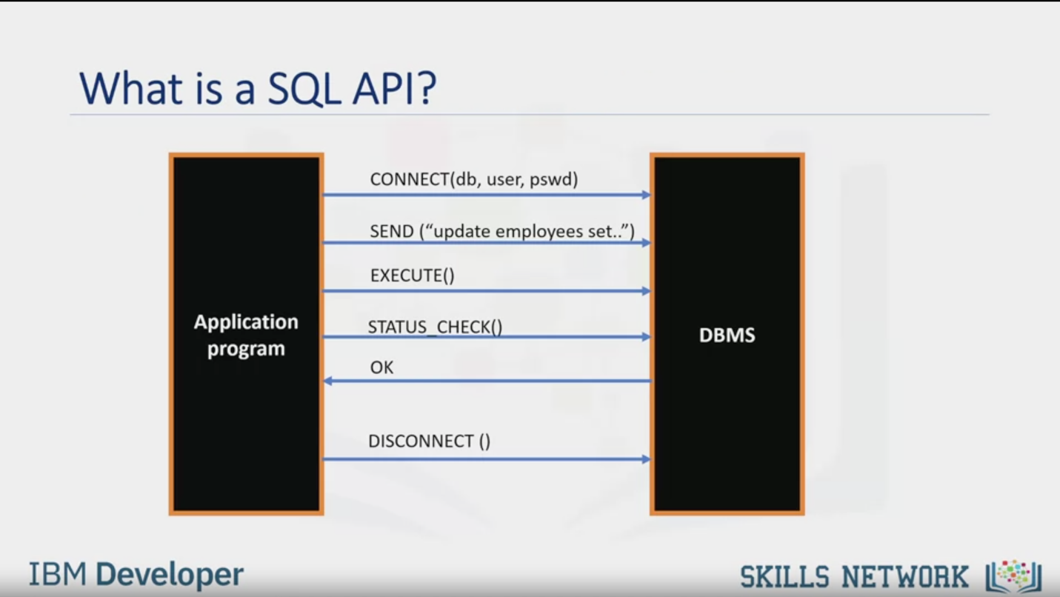

What is a SQL API?

Application

program

CONNECT(db, user, pswd)

SEND ("update employees set."

EXECUTE()

STATUS CHECK()

OK

DBMS

DISCONNECT ()

IBM Developer

SKILLS NETWORK

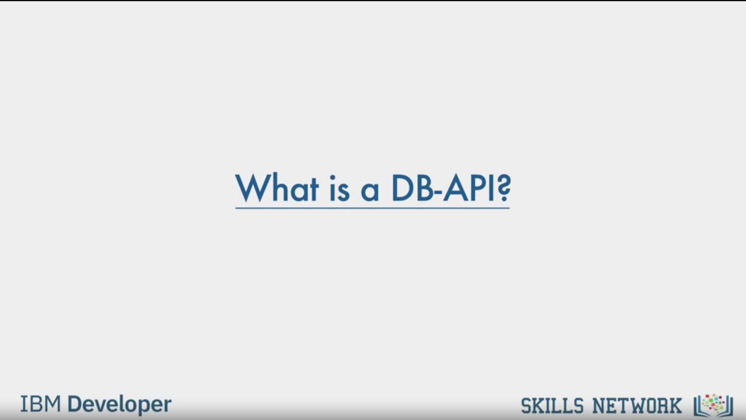

What is a DB-API?

IBM Developer

SKILLS NETWORK

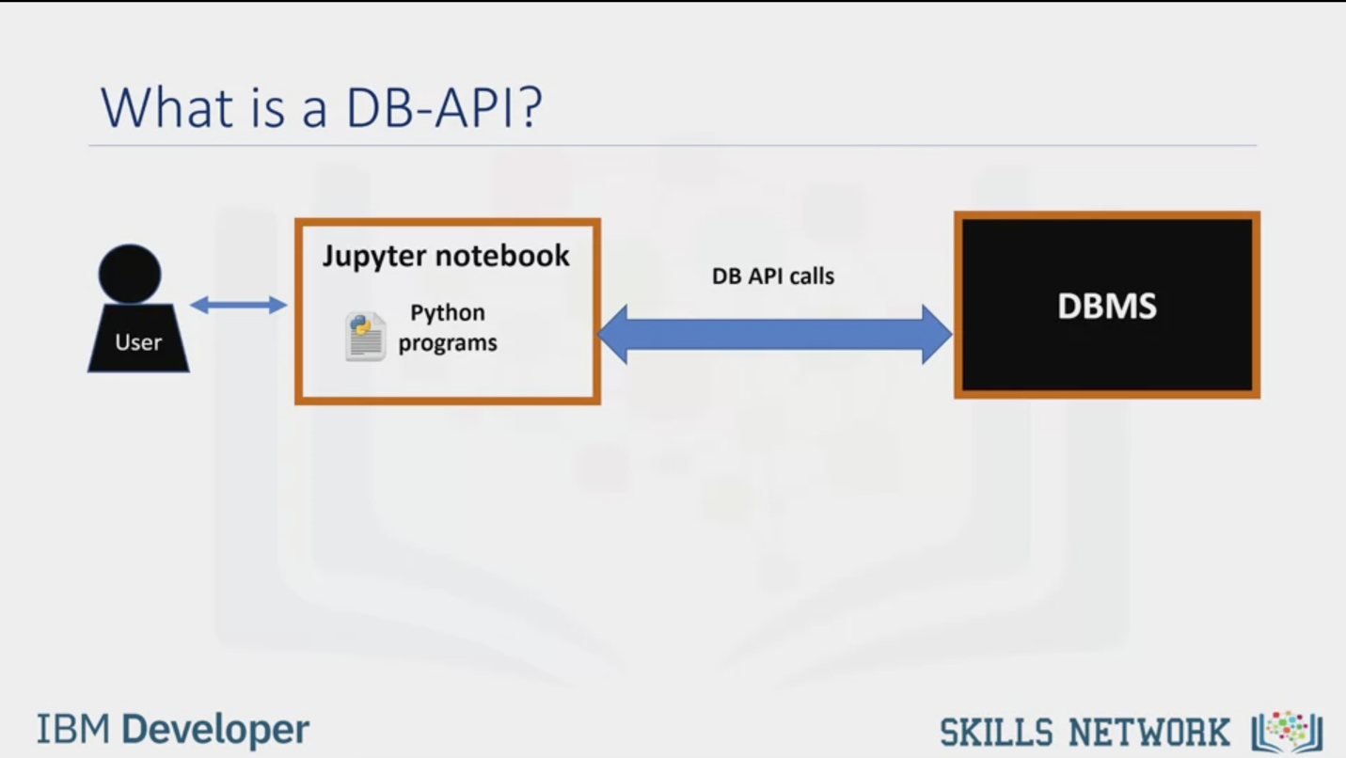

What is a DB-APl?

User

Jupyter notebook

Python

programs

IBM Developer

DB API calls

DBMS

SKILLS NETWORK

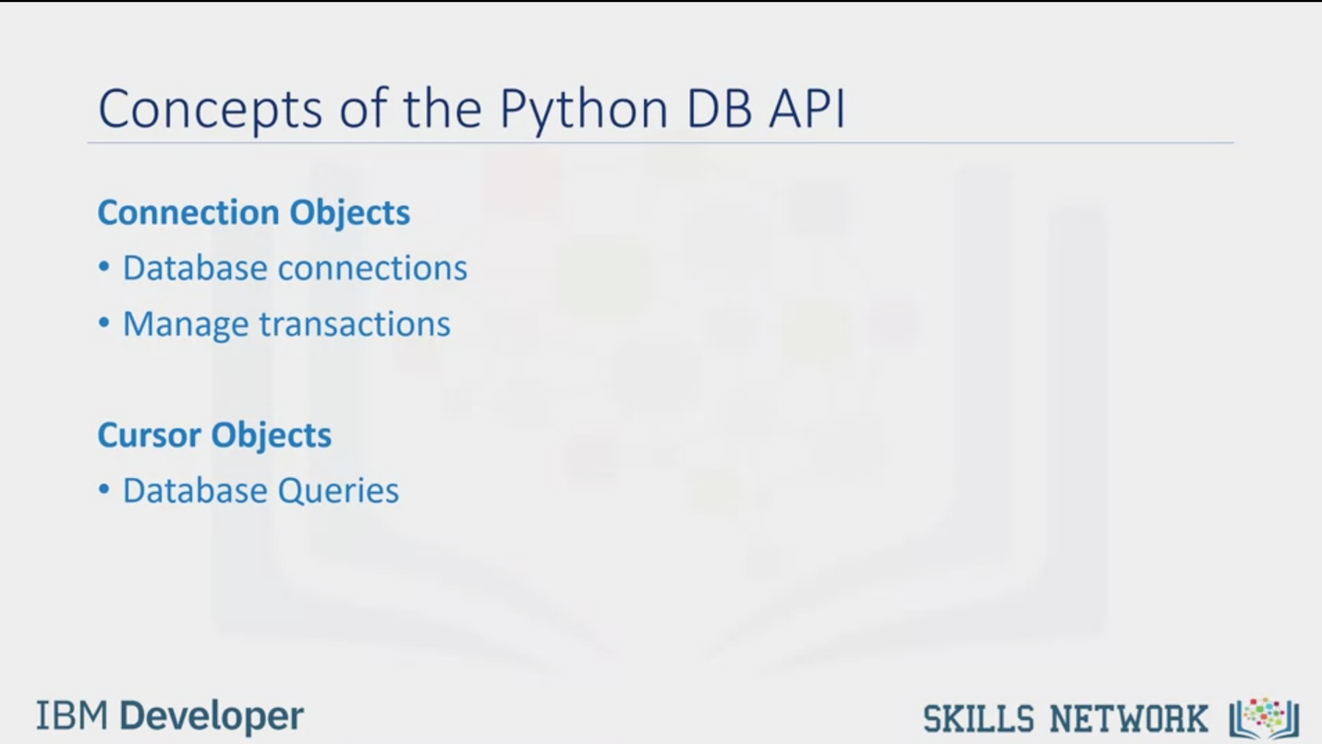

Concepts of the Python DB API

Connection Objects

• Database connections

• Manage transactions

Cursor Objects

• Database Queries

IBM Developer

SKILLS NETWORK

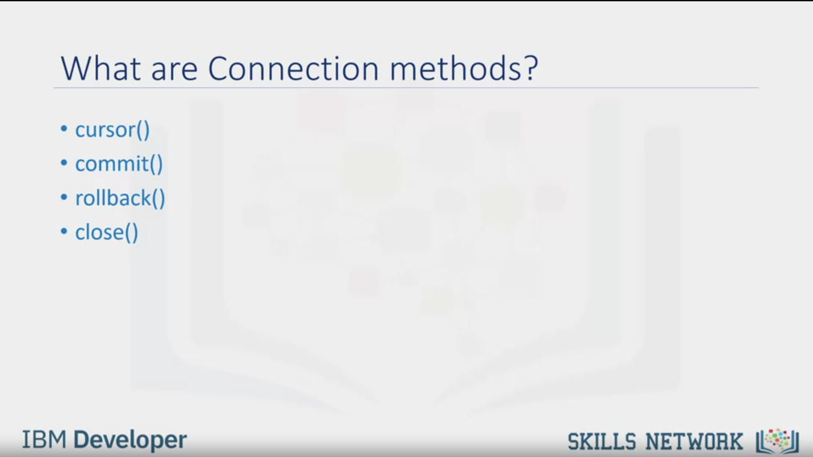

What are Connection methods?

• cursor()

• commit

• rollback()

• close )

IBM Developer

SKILLS NETWORK

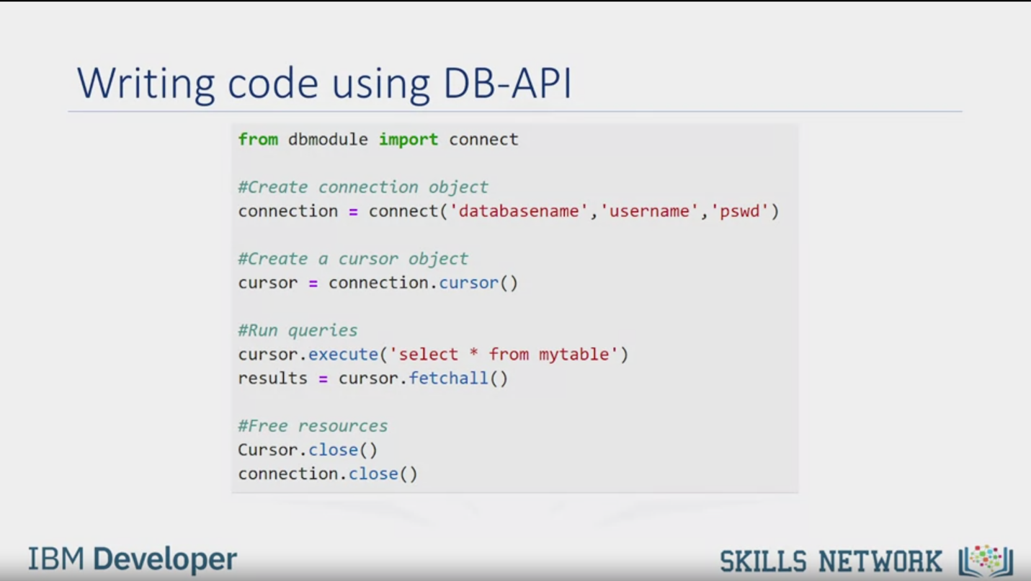

Writing code using DB-API

from dbmodule import connect

#Create connection object

connection = connect ('databasename', 'username', 'pswd')

#Create a cursor object

cursor = connection.cursor()

#Run queries

cursor.execute('select * from mytable')

results = cursor.fetchall()

#Free resources

Cursor.close()

connection.close()

IBM Developer

SKILLS NETWORK

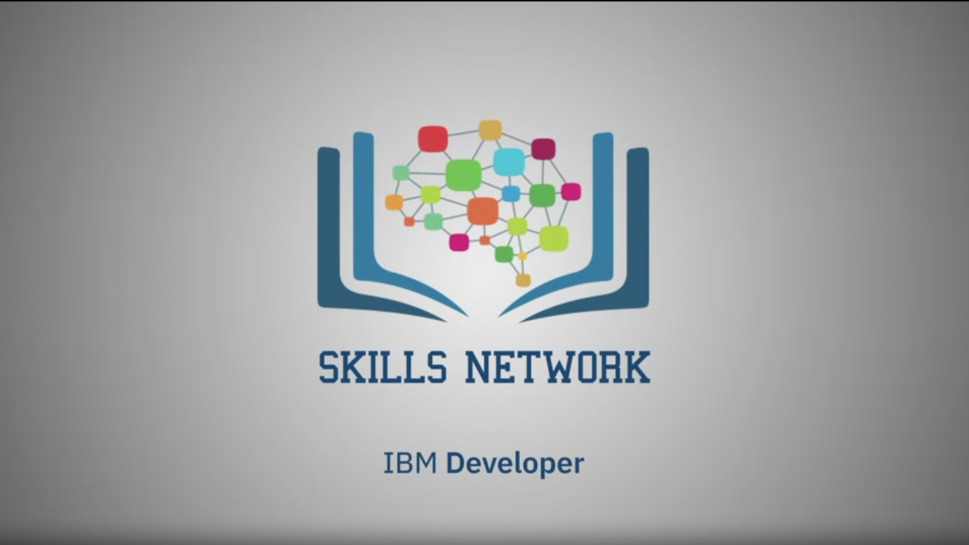

SKILLS NETWORK

IBM Developer

Hello, in this video you will learn how to access databases using Python.

Databases are powerful tools for data scientists.

After completing this module, you'll be able to explain the basic concepts related to using

Python to connect to databases.

This is how a typical user accesses databases using Python code written on a Jupyter notebook,

a web based editor.

There is a mechanism by which the Python program communicates with the DBMS.

The Python code connects to the database using API calls.

We will explain the basics of SQL APIs and Python DB APIs.

An application programming interface is a set of functions that you can call to get

access to some type of service.

The SQL API consists of library function calls as an application programming interface, API,

for the DBMS.

To pass SQL statements to the DBMS, an application program calls functions in the API, and it

calls other functions to retrieve query results and status information from the DBMS.

The basic operation of a typical SQL API is illustrated in the figure.

The application program begins its database access with one or more API calls that connect

the program to the DBMS.

To send the SQL statement to the DBMS, the program builds the statement as a text string

in a buffer and then makes an API call to pass the buffer contents to the DBMS.

The application program makes API calls to check the status of its DBMS request and to

handle errors.

The application program ends its database access with an API call that disconnects it

from the database.

DB-API is Python's standard API for accessing relational databases.

It is a standard that allows you to write a single program that works with multiple

kinds of relational databases instead of writing a separate program for each one.

So, if you learn the DB-API functions, then you can apply that knowledge to use any database

with Python.

The two main concepts in the Python DB-API are connection objects and query objects.

You use connection objects to connect to a database and manage your transactions.

Cursor objects are used to run queries.

You open a cursor object and then run queries.

The cursor works similar to a cursor in a text processing system where you scroll down

in your result set and get your data into the application.

Cursors are used to scan through the results of a database.

Here are the methods used with connection objects.

The cursor() method returns a new cursor object using the connection.

The commit() method is used to commit any pending transaction to the database.

The rollback() method causes the database to roll back to the start of any pending transaction.

The close() method is used to close a database connection.

Let's walk through a Python application that uses the DB-API to query a database.

First, you import your database module by using the connect API from that module.

To open a connection to the database, you use the connection function and pass in the

parameters that is, the database name, username, and password.

The connect function returns connection object.

After this, you create a cursor object on the connection object.

The cursor is used to run queries and fetch results.

After running the queries using the cursor, we also use the cursor to fetch the results

of the query.

Finally, when the system is done running the queries, it frees all resources by closing

the connection.

Remember that it is always important to close connections to avoid unused connections taking

up resources.Thanks for watching this video.